MIRO – Vendor Invoice for Expense Booking with PO
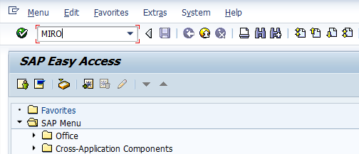
- Input MIRO in Transaction box and press Enter key

Document Header Data Information
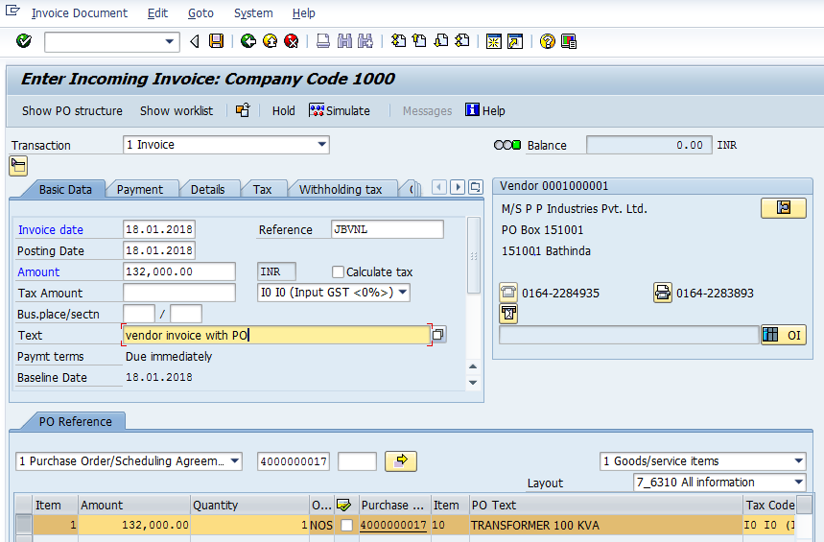
The following are the Input fields under the Document Header data of MIRO
- Invoice Date: Input the Invoice date in the field
- Posting Date: Input the transaction date in the Posting date field
- Currency: Input the Currency INR in the Currency field
- Reference: Input the Reference field with Reference (invoice) number
- Amount: Input the Amount as per the Purchase order
- Text: Input the Text Information in text field
- Calculate Tax: Check the Calculate Tax check box for calculating tax. Select respective tax from drop down list

Document Line Item Data
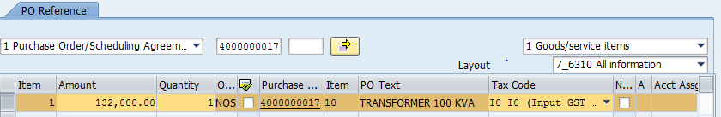

The following are the Input fields under the Line Item data of MIRO
- Input the Purchase Order (PO) in the PO field and Press Enter Key
- System will populate the information with respect to Purchase order
- Amount: Amount updated in the PO will appear in this field
- Quantity: Quantity provided in PO will appear in this field
- Purchase Order: Purchase Order information will appear in this field
- Tax code: The tax code provided in PO will appear here
- Material: Material Number will appear in this field

Simulation of Transaction before posting:
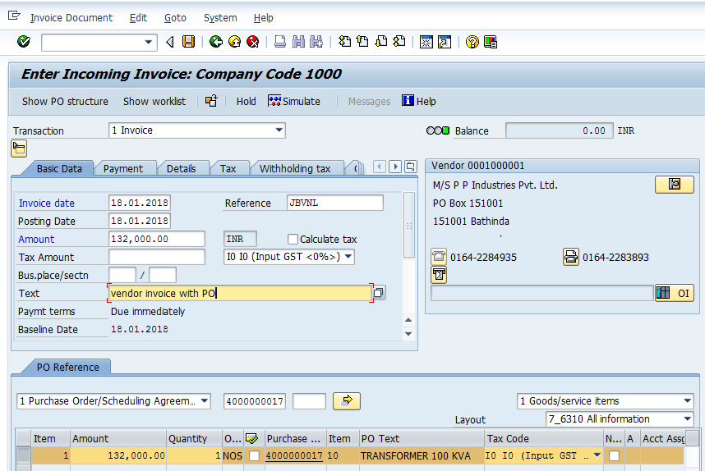
Simulate: Click on Simulate option. System will display the line items (Debit and Credit entry).
- Check the entries, if the entries are correct, click to Post Button
- If the entries are not okay, then go to Main screen and take required action to correct it.
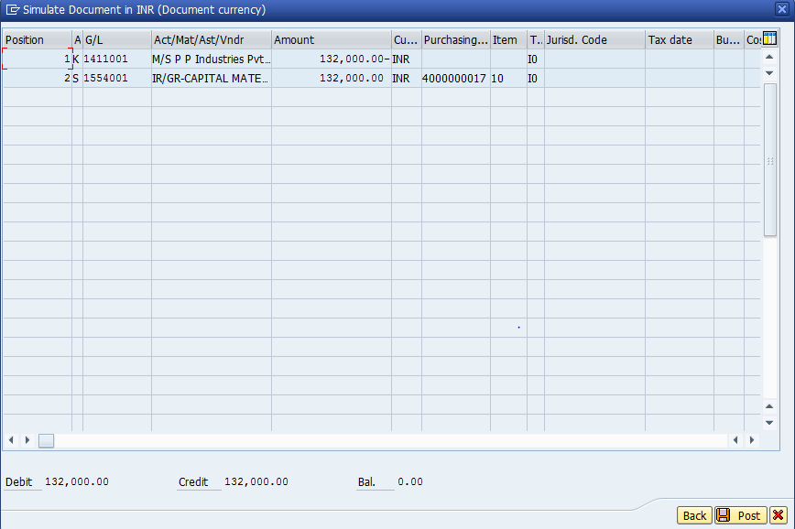

Document Posting
- Document is posted, An information will be populated at the bottom of the screen

Document Display View
Click on Invoice option in Menu bar and select Display option
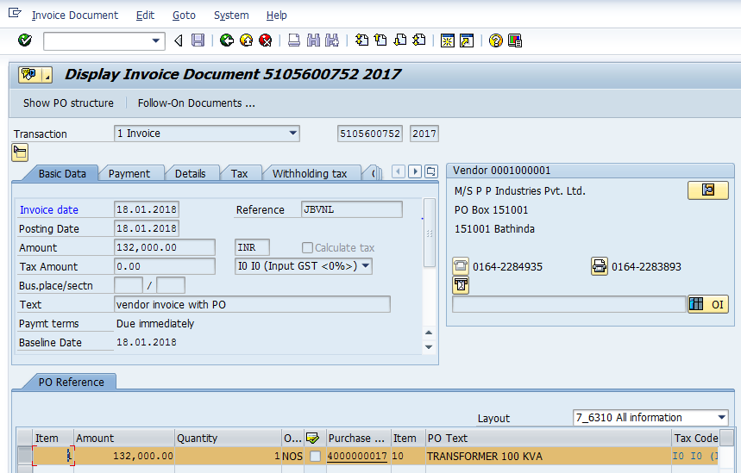
Click on Follow on Documents… option system will display the transaction posted
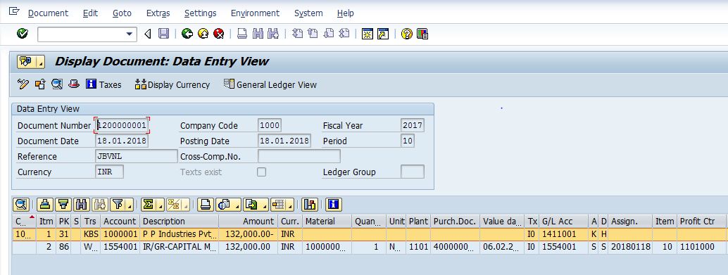
Manual End

